Design Changes for Bantleon 29/05/2024
All pages:
- Ensure that throughout the report anywhere CO₂ appears, that it is stylised like so, with the 2 as a sub number.
Page 3 – Make “Was ist unser Vergleichsvermögen und wie wird es ermittelt?“ text colour: #4A5E00
Please also make the word Datengrundlage into a title, the same as how Benchmark Zusammensetzung appears.
Please place the Datengrundlage texts below further down the page, so they are closer to the foot note, and a gap will appear beneath

100% iShares Core MSCI World UCITS ETF:
“Datengrundlage
Alle ESG-Kennzahlen basieren (sofern nicht explizit gekennzeichnet) auf Daten von MSCI ESG Research LLC (MSCI). Einzelne, entsprechend gekennzeichnete ESG-Kennzahlen stammen von ISS ESG. Die Berechnungen basieren auf den unterliegenden Beständen des Fonds. Weitere Details zur Methodologie der einzelnen Kennzahlen können auf den Websites der Datenanbieter abgerufen werden.“
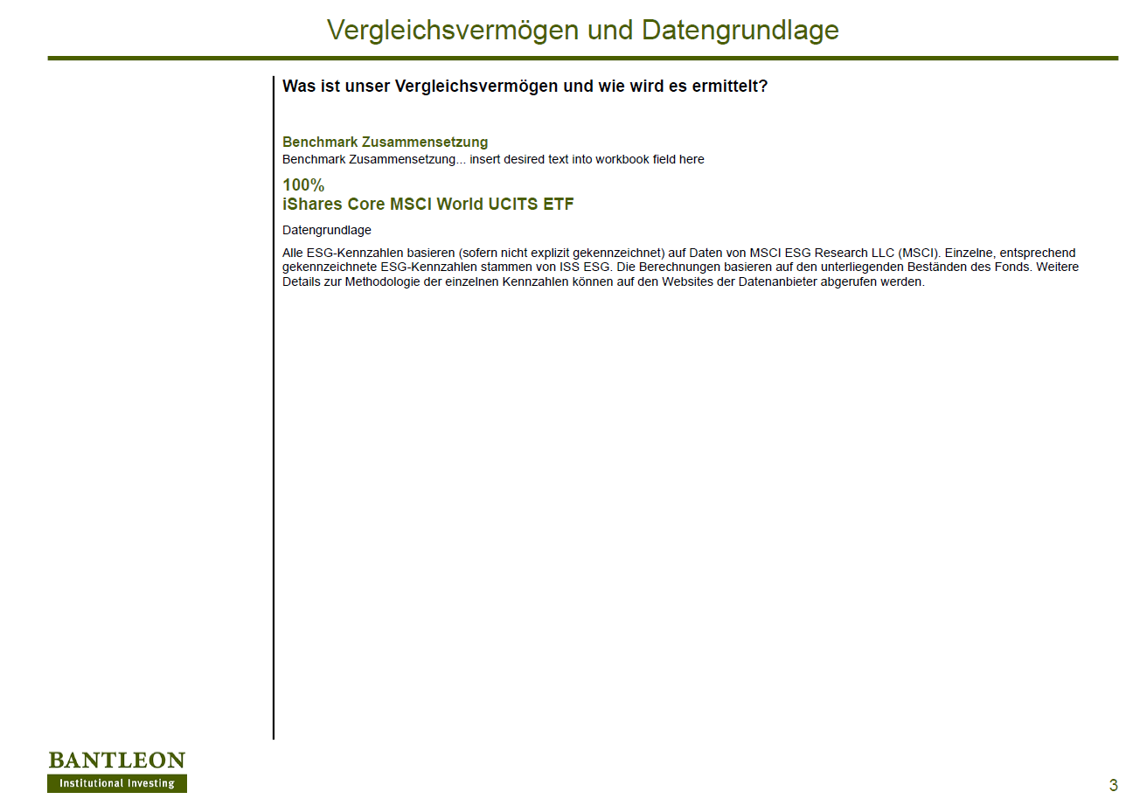

Page 4 – Überblick
Please design this page like how it was before (see second image below), with the correct coloured fonts and boldness, and the 3 boxes. Please make the boxes around the texts a solid line.
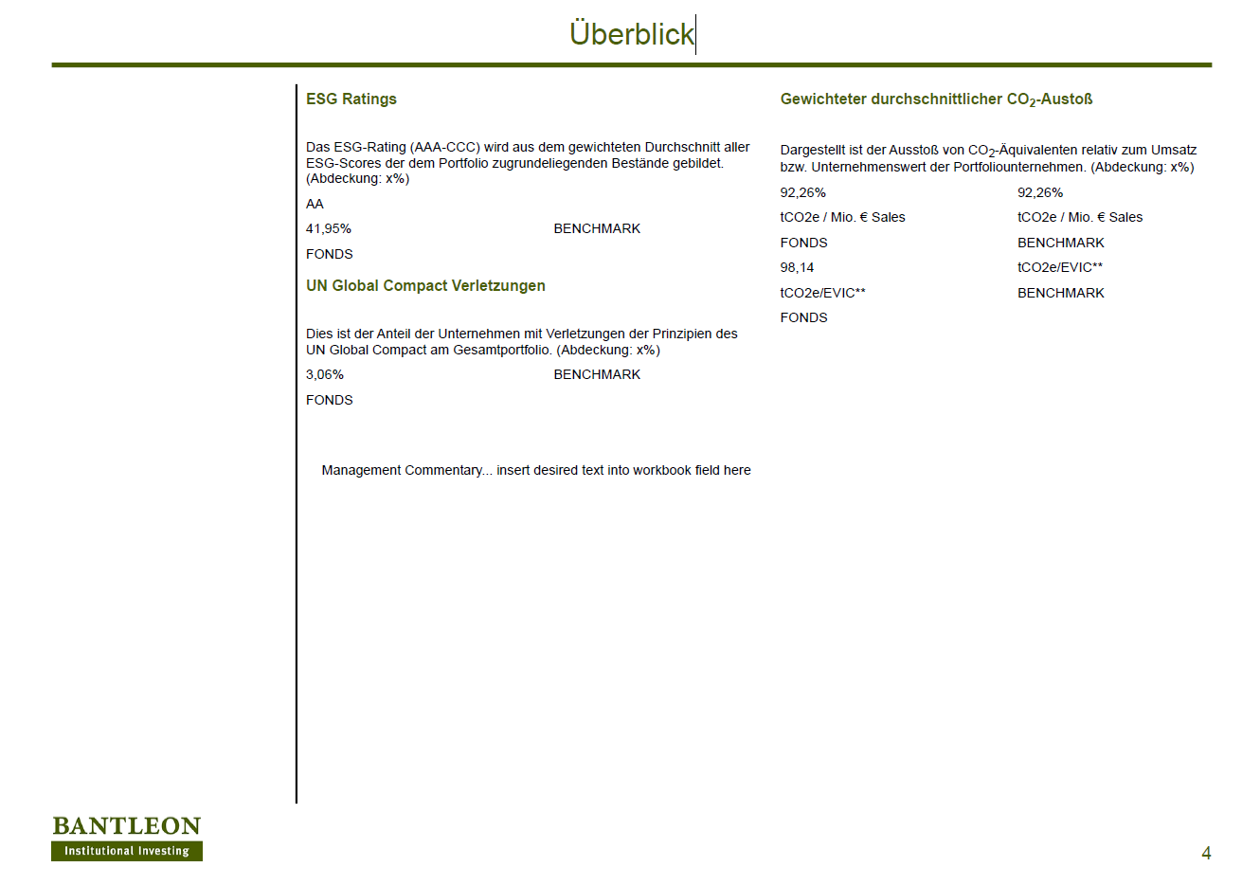
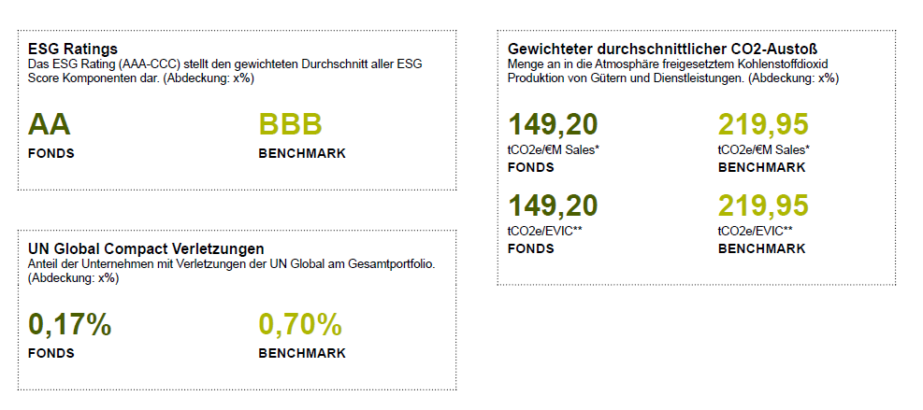
Page 6 - ESG-Rating
Please design this section (first image), like how it was before (second image) – With the correct coloured fonts and boldness for
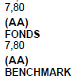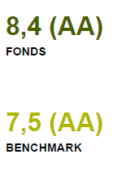
Please can you also place the number “92,26%” in placement of the “x%”?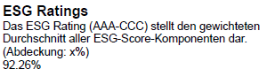
Page 9 – International Normen
Please can you also place the number “92,26%” in placement of the “x%”?
Please can you also design the 3,06% like how it was before with the colours and boldness, like the 0,17% etc. below?
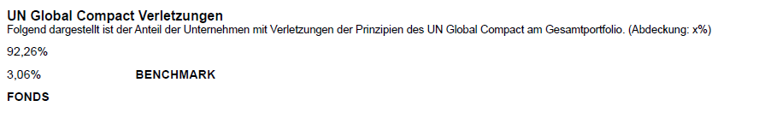
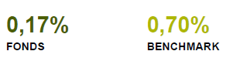
Page 10 – Kritische Geschäftsfelder
Please can you also place the number “92,26%” in placement of the “x%”?
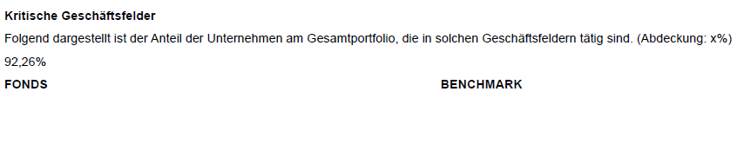
Page 11 – Kontroversen
Please redesign the word BENCHMARK to appear like FONDS.

Page 13 – Emissionen
Please redesign this page (first image), to look like how it did previously (second image).
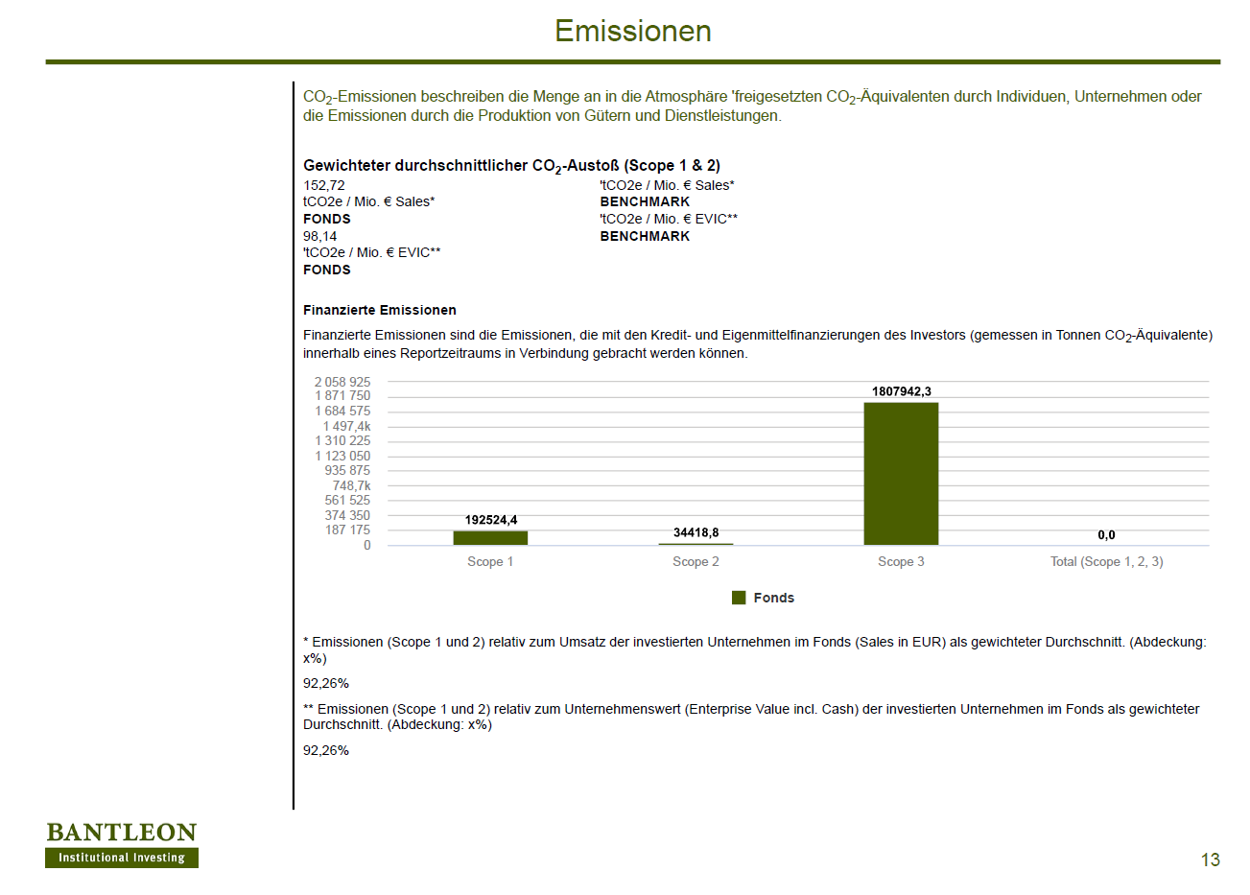
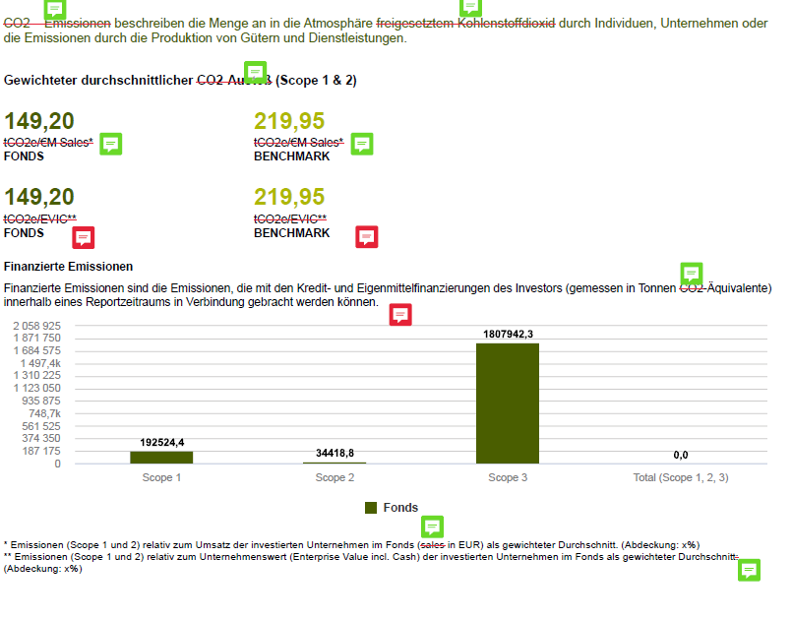
PLEASE IGNORE THE COMMENT BOXES AND THE RED CROSSED OUT TEXT SECTIONS. Please change the numbers to be bold with the correct colours.
On the same page (page 13), please also place the number “92,26%” in placement of the “x%”? See below:
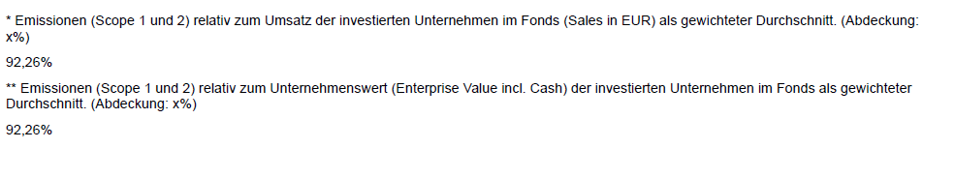
Page 14 – Emissionen
Please can you add these images beside the static text? The images can be found from the original mock up.
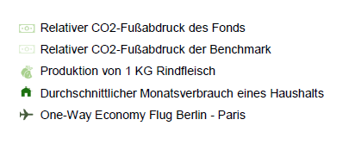
On the same page (page 14), please place the number 98,14 in place of the “x”.
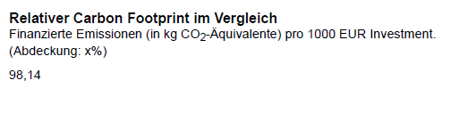
Page 15 – Emissionen
Please can the text “Die auf dieser Seite dargestellten Werte basieren auf Daten von ISS ESG“ appear at the bottom of the page like a foot note, in smaller text.
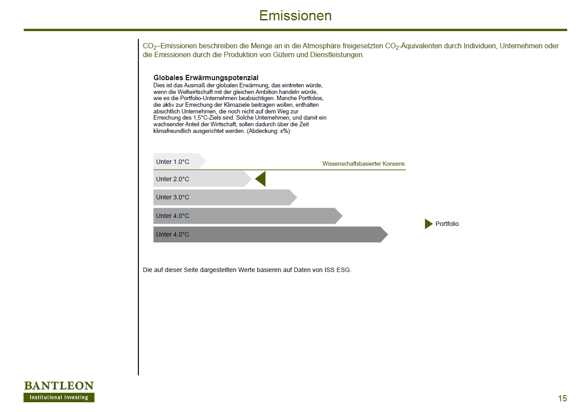

Page 17 – Title Page: Nachhaltige Wirkung
Please can the title of this page appear like the one below (white text and correct size).

Page 18 - Impact Revenue
Please can the images be added in place of the dummy squares. I was only able to download .svg files from this website and I could not open them. I’ve provided the name, HTML code from the site, and the link to the image. I hope this is sufficient. Please let me know if not.
Alternative Energien
Image: Sun
HTML: <i class="fas fa-sun" style="color: #ffffff;"></i>
https://fontawesome.com/v5/icons/sun?f=classic&s=solid&pc=%23ffffff
Energieeffizienz
Image: Plug
HTML: <i class="fas fa-plug" style="color: #ffffff;"></i>
https://fontawesome.com/v5/icons/plug?f=classic&s=solid&pc=%23ffffff
Nachhaltiges Bauen
Image: Building
HTML: <i class="fas fa-building" style="color: #ffffff;"></i>
https://fontawesome.com/v5/icons/building?f=classic&s=solid&pc=%23ffffff
Nachhaltige Wasserwirtschaft
Image: Water drop (tint)
HTML: <i class="fas fa-tint" style="color: #ffffff;"></i>
https://fontawesome.com/v5/icons/tint?f=classic&s=solid&pc=%23ffffff

Verschmutzungs Prävention
Image: Recycle
HTML: <i class="fas fa-recycle" style="color: #ffffff;"></i>
https://fontawesome.com/v5/icons/recycle?f=classic&s=solid&pc=%23ffffff
Nachhaltige Landwirtschaft
Image: Leaf
HTML: <i class="fas fa-leaf" style="color: #ffffff;"></i>
https://fontawesome.com/v5/icons/leaf?f=classic&s=solid&pc=%23ffffff
Ernährung
Image: Utensils
HTML: <i class="fas fa-utensils" style="color: #ffffff;"></i>
https://fontawesome.com/v5/icons/utensils?f=classic&s=solid&pc=%23ffffff
Erschwingliche Immobilien
Image: Home
HTML: <i class="fas fa-home" style="color: #ffffff;"></i>
https://fontawesome.com/v5/icons/home?f=classic&s=solid&pc=%23ffffff
Therapien für bedeutende Krankheiten
Image: Syringe
HTML: <i class="fas fa-syringe" style="color: #ffffff;"></i>
https://fontawesome.com/v5/icons/syringe?f=classic&s=solid&pc=%23ffffff
Sanitation
Image: toilet-paper
HTML: <i class="fas fa-toilet-paper" style="color: #ffffff;"></i>
https://fontawesome.com/v5/icons/toilet-paper?f=classic&s=solid&pc=%23ffffff
KMU- Finanzierungen
Image: Coins
HTML: <i class="fas fa-coins" style="color: #ffffff;"></i>
https://fontawesome.com/v5/icons/coins?f=classic&s=solid&pc=%23ffffff
Bildung
Image: graduation-cap
HTML: <i class="fas fa-graduation-cap" style="color: #ffffff;"></i>
https://fontawesome.com/v5/icons/graduation-cap?f=classic&s=solid&pc=%23ffffff
Konnektivität
Image: broadcast-tower
HTML: <i class="fas fa-broadcast-tower" style="color: #ffffff;"></i>
https://fontawesome.com/v5/icons/broadcast-tower?f=classic&s=solid&pc=%23ffffff
Page 23 – Zielfondsanalyse
Please can this table:

Be designed like this table:
